  - This paragraph is a description of the modification to the Progenitor Pipeline Analysis as described in Kalebic et., al 2019 [1], and it is intended to be used as an implementation of the Material and Methods section.
  - The following modifications were performed from the additional pipeline:
- The macro (ProgenitorProcessesAnalysis_v.2.0) is now updated to be used on new version of Fiji. The current analyses were performed with Fiji v. 10.03.05.

  - Briefly, the cells were acquired with a step size of 0.3 μm using a point-scanning confocal systems: either a Leica Stellaris 8 with a Plan-Apochromat 40×/1.3 NA oil immersion objective or a Zeiss LSM980 with a Plan-Apochromat 40×/1.4 NA oil immersion objective. Basal progenitors were distinguished as GFP+ Ki67+ cells in the SVZ and cropped within an area of at least 53 μm x 53 μm surrounding the cell. Cell outline was manually tracked following the GFP signal through the Z stack usingTrackEM2 plugin (Fiji v. 10.03.05). The obtained cell mask was applied to the abovementioned pipeline and the results obtained were plotted in Excel along with other cell morphological parameters. A few seconds are required for the macro to process the manually-annotated cell outline.
  - For additional details regarding the installation and running of the macro, we refer to the original description provided in Kalebic et al., 2019 [1].

  - PPA script documentation

Contents
1. Introduction 1
2. Progenitors Processes Analysis (PPA) 1
2.1. Overview 1
2.2. Installation 2
2.3. Usage 2
3. Bibliography: 5

Introduction
For each plugin, the overview paragraph is a high level description that is intended to appear in materials and methods of the paper. The following sections contain additional details on the installation, usage and methods used. They are intended for the supplementary materials.

Progenitors Processes Analysis (PPA)

Overview
To characterize morphology of the individual neuronal progenitors we developed a semi manual workflow. Images used for this application were acquired on the confocal microscope with the 40x objective as cca 50-μm thick stacks of the 1-μm thick optical sections. Individual cells are first annotated manually with Fiji plugin trakEM2 [2] and exported as 2D masks for further analysis. Each cell is processed to create a mask of the cell body and a skeleton [3] of the processes. The cell body mask is then combined with the processes skeleton, forming a simplified representation of the cell that can be used for its characterization. If necessary the cell body mask can be corrected manually during the process. In that representation, each process is a branching tree. It is in contact with the cell body at a single position, may or may not divide in multiple branches defining one or more extremities. For each progenitor the number of processes, the total number of process extremities, the branching index (ratio of extremities of the processes count) and the cell body (soma) radius are measured. Additionally, a Sholl analysis [4] which consists in counting the number of branches intersecting a circle of radius k.R, is performed. Practically R is the radius of the cell body and k is chosen in {2,3,4}. For each process we also characterize its length and tortuosity. Finally, for each analysed cell a visualization is generated for visual inspection of the cell body and the detect processes. This analysis was implemented as a script for the freely available Fiji software [5,6]. The script was tested with Fiji current version: (Fiji is just ImageJ) ImageJ 2.0.0-rc-61/1.51n. The source code of the script and its helper library are available on an online repository. Additional details on the installation and usage of the analysis tool can be found in the following sections.

Installation
In order to install the neuronProcessesAnalysis script:
- Install a fresh version of Fiji from https://imagej.net/Downloads . in particular Fiji comes preinstalled with Skeletonize3D and Analyze Skeleton (2D/3D) plugin that will be used for the analysis.
- Download neuronProcessesAnalysis.py script from the project repository¹. When unzipped it should contain 2 files: neuronProcessesAnalysis_v1.3.1.py and SkeletonAnalysis_-1.2.0.jar
- Copy the jar file to the plugins directory of you Fiji installation and save the python script to your hard drive.

Usage
Cell and their processes can be annotated with the FIJI plugin trackEM2. This can be done by importing an image stack into trakEM2. The cell of interest can then be annotated with the brush tool after creating a new AreaList. The resulting mask can then be exported by choosing the item Export > Image stack under the selected AreaList in the context menu. This image can then be projected along the z axis to form a 2d image and saved to disk for further analysis.
In order to use the neuronProcessesAnalysis script, open the script in Fiji and click the run button in the script editor. A window will appear requesting the image analysis parameters (see Figure 1):
- Image to Analyze: the path to the file of the 2D cell mask to analyze
- Minimum branch length: the minimum length of a branch in a process to be considered in the analysis
- Maximum branch width: all structure with a larger width will be considered soma or junction in the analysis.
- Define a region of interest: If checked the script will pause after opening the image selected by opening a message window proposing the user to draw a region to analyse in the image. Validating the message window will let the script proceed.
- Manually update soma mask: if checked the script will pause by opening a message window proposing the user to update the current soma detection with the brush selection tool. The brush selection tool size can be modified if needed by double clicking on its icon. Validating the message window will let the script proceed.
- Use image calibration: if checked the script will use the pixel size defined in image metadata (pixel size can be checked by going to Fiji menu Image>Properties … ). Otherwise an isotropic pixel size of one is used.
- Save results: if checked, all measures and visualisation created to support the analysis validation are save the analyze image folder on disk.
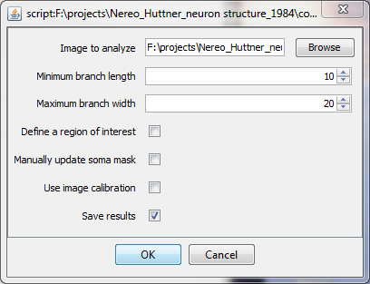
Figure 1: Window requesting parameters when starting the image neuronProcessesAnalysis script
When validating the parameter window the script will proceed with analysis possibly pausing for additional user input if the option Define a region of interest and/or Manually update soma mask are checked. At the end of the analysis the script will produce 2 results tables, one visualisation of the detected structures overlaid to the mask and a list of path in the roi manager describing the shortest path from each processes extremities to the cell body. The first results table is named “Neuron Analysis – cell Information” and shows the cell measures (see Figure 2):
- Folder name: the name of directory containing the analysed image
- Image Name: The file name of the analysed image
- Cell type: the cell type as indicated in the folder name string after the last underscore
- # processes: the number of processes detected
- # end points: the number of end point detection
- Soma R: the radius of the cell body
- Sholl kR: the number of branches cutting a circle of radius k times the soma radius
- Process branching: ratio of the number of branching point to the number of processes
The second results table is named “Neuron Analysis – process Information” and shows measures for each individual processes (see Figure 3):
- Folder name: the name of directory containing the analysed image
- Image Name: the file name of the analysed image
- Process Id: a number to identify the processes
- Longest path name: the name of the longest of the shortest path traced between a process extremities and the cell body. The path name is of the form process-X-Y where X is the process Id and Y is an identifier to distinguish the path in a process. This name correspond the path name listed in the roi manager. Clicking one of these path in the roi manager will display it on the cell mask allowing to check if the process were correctly detected.
- Process Length: the length, along the path, of the longest path in the process considered
- Process Euclidean length: the distance between the longest shortest path extremities.
- Length ratio: also called tortuosity it is the ration of the process length to the Euclidean process length
The results image show the cell mask overlayed by the detected processes and cell body (blue), the longest shortest path in each process (green), and Sholl circles (cyan) for radius 2,3 and 4 times the cell body radius. In case the processes skeleton contains loop some branch can appear in red if they are used by none of the shortest path in the process. Details of cell processes construction and characterisation can be found in the source code of the script.

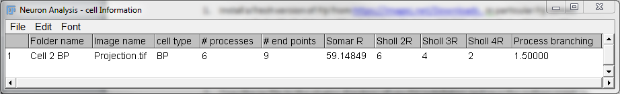
Figure 2: example of cell measures table obtained after analyzing one cell

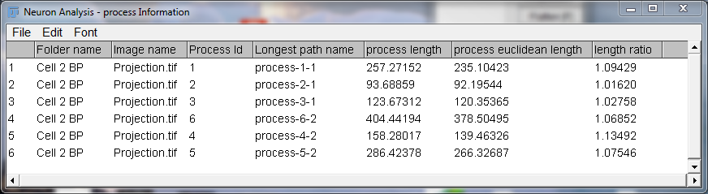
Figure 3: example of cell processes measures obtained from the analysis of one cell.

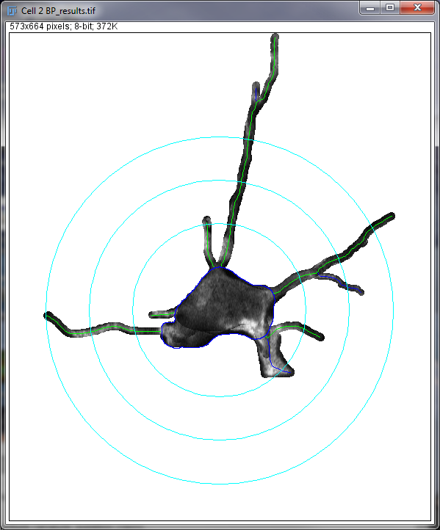
Figure 4: example of result images obtained from the analysis of a cell mask.

Bibliography:

[1] Kalebic, N., Gilardi, C., Stepien, B., Wilsch-Bräuninger, M., Long, K. R., Namba, T., Florio, M., Langen, B., Lombardot, B., Shevchenko, A., Kilimann, M. W., Kawasaki, H., Wimberger, P., & Huttner, W. B. (2019). Neocortical Expansion Due to Increased Proliferation of Basal Progenitors Is Linked to Changes in Their Morphology. Cell Stem Cell, 24(4), 535-550.e9. https://doi.org/10.1016/j.stem.2019.02.017

[2] Cardona, A., Saalfeld, S., Schindelin, J., Arganda-Carreras, I., Preibisch, S., Longair, M., ... & Douglas, R. J. (2012). TrakEM2 software for neural circuit reconstruction. PloS one, 7(6), e38011.
[3] Arganda‐Carreras, I., Fernández‐González, R., Muñoz‐Barrutia, A., & Ortiz‐De‐Solorzano, C. (2010). 3D reconstruction of histological sections: application to mammary gland tissue. Microscopy research and technique, 73(11), 1019-1029.
[4] Sholl, D. A. (1953). Dendritic organization in the neurons of the visual and motor cortices of the cat. Journal of anatomy, 87(Pt 4), 387.
[5] Schindelin, J., Arganda-Carreras, I., Frise, E., Kaynig, V., Longair, M., Pietzsch, T., ... & Tinevez, J. Y. (2012). Fiji: an open-source platform for biological-image analysis. Nature methods, 9(7), 676-682.
[6] Schneider, C. A., Rasband, W. S., & Eliceiri, K. W. (2012). NIH Image to ImageJ: 25 years of image analysis. Nature methods, 9(7), 671.

neuronProcessesAnalysis script code: https://git.mpi-cbg.de/scicomp/kalebic_et_al_progenitors_processes_analysis Source code of the SkeletonAnalysis library: https://git.mpi-cbg.de/bioimage-informatics/SkeletonAnalysis

